Tuesday, January 24, 2017

Supporting Local Education through Donations
Dear Walmart:
It is easy to see that people in our metropolitan area have unmet needs. The gravity of the situation is seen in the number of Adventist families who are struggling and unemployed. The number of students on state scholarship programs has increased within many of our smaller and mid-sized schools. At Osceola Adventist Christian School (OACS) our percentage of students on state scholarships is 90%. These families are unable to contribute to the school for lack of resources, not lack of desire.
For over 20 years OACS has worked hard to provide a quality, standards-based Adventist Education in Kissimmee. The Kissimmee-St.Cloud area has a growing Adventist community and OACS is the only Seventh-day Adventist School in the south Orlando Metropolitan area. Our desire and mission has been to reach out to our Adventist families and help them to see that they have an alternative educational venue that was inspired by the Holy Spirit, and that our church and its various institution places much value and financial resources into every year. The response has been positive as the school has grown by more than 30% in the last four years.
To continue our mission, however, necessitates a strong financial foundation, which is built by compassionate and mission-minded individuals like you. We appreciate your faithful support of education and helping to meet our various schools’ needs across Florida. Indeed, OACS has our own part to do in finding solutions for our problems. The level of support we are requesting will help us considerably as we provide quality education to our struggling families who are below the poverty line.
A donation of art materials and school supplies will help our teachers who have worked for three years without classroom budgets, and our families who struggle to make ends meet. We deeply appreciate your support of Education and specifically our mission here in Kissimmee.

In the Service of Christ Jesus,
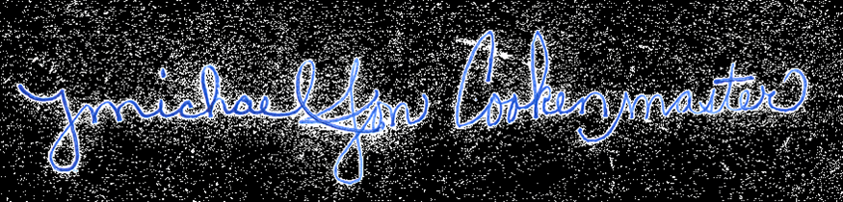
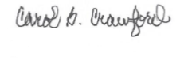

Michael Jon Cookenmaster Mrs. Carol B. Crawford
Principal Board Chair

