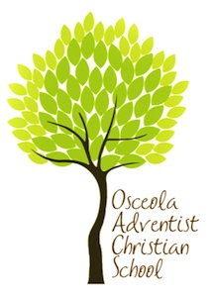

**Osceola Adventist Christian School**

**specializes in creating experiences**

**that foster a lifelong love of learning.**

**Through inviting classrooms, engaging**

**teachers, Bible-based common**

**core standards curriculum,**

**and an environment**

**where all abilities are honored,**

**a passion for knowledge**

**takes root**.

**Mission Statement**   
The Osceola Adventist Christian School family exists to *show* children Jesus, *nurture* their love for Him and others, *teach* them to think, and *empower* them to serve.  
  
**Our Educational Philosophy**   
A belief in the existence of the Creator God is fundamental in the philosophy of Osceola Adventist Christian School. We respect His divine authority and recognize His intervention in human affairs. We believe that true education develops the spiritual, mental, and physical powers of each student; preparing them for the joy of service in this life and for the higher joy of service in the life to come.

**Our Curriculum**The Osceola Adventist Christian School (OACS) operated in harmony with the guidance and direction of the Office of Education, North American Division of the Seventh-day Adventist Church. OACS offers students the opportunity to

* develop a personal relationship with God and our fellow men
* master the basic academic skills (NAD common core curriculum)
* value creation through physical and mental labor, as the blessing God intended (agriculture class)
* cultivate physical fitness, mental ability, and moral purity as the blessing God intended (physical education, 3-8 choir, and VPK-2 hand bells)

| A Reason for Being

A Journey to Excellence

Osceola Adventist Christian School

*Christian Education with Solid Roots*

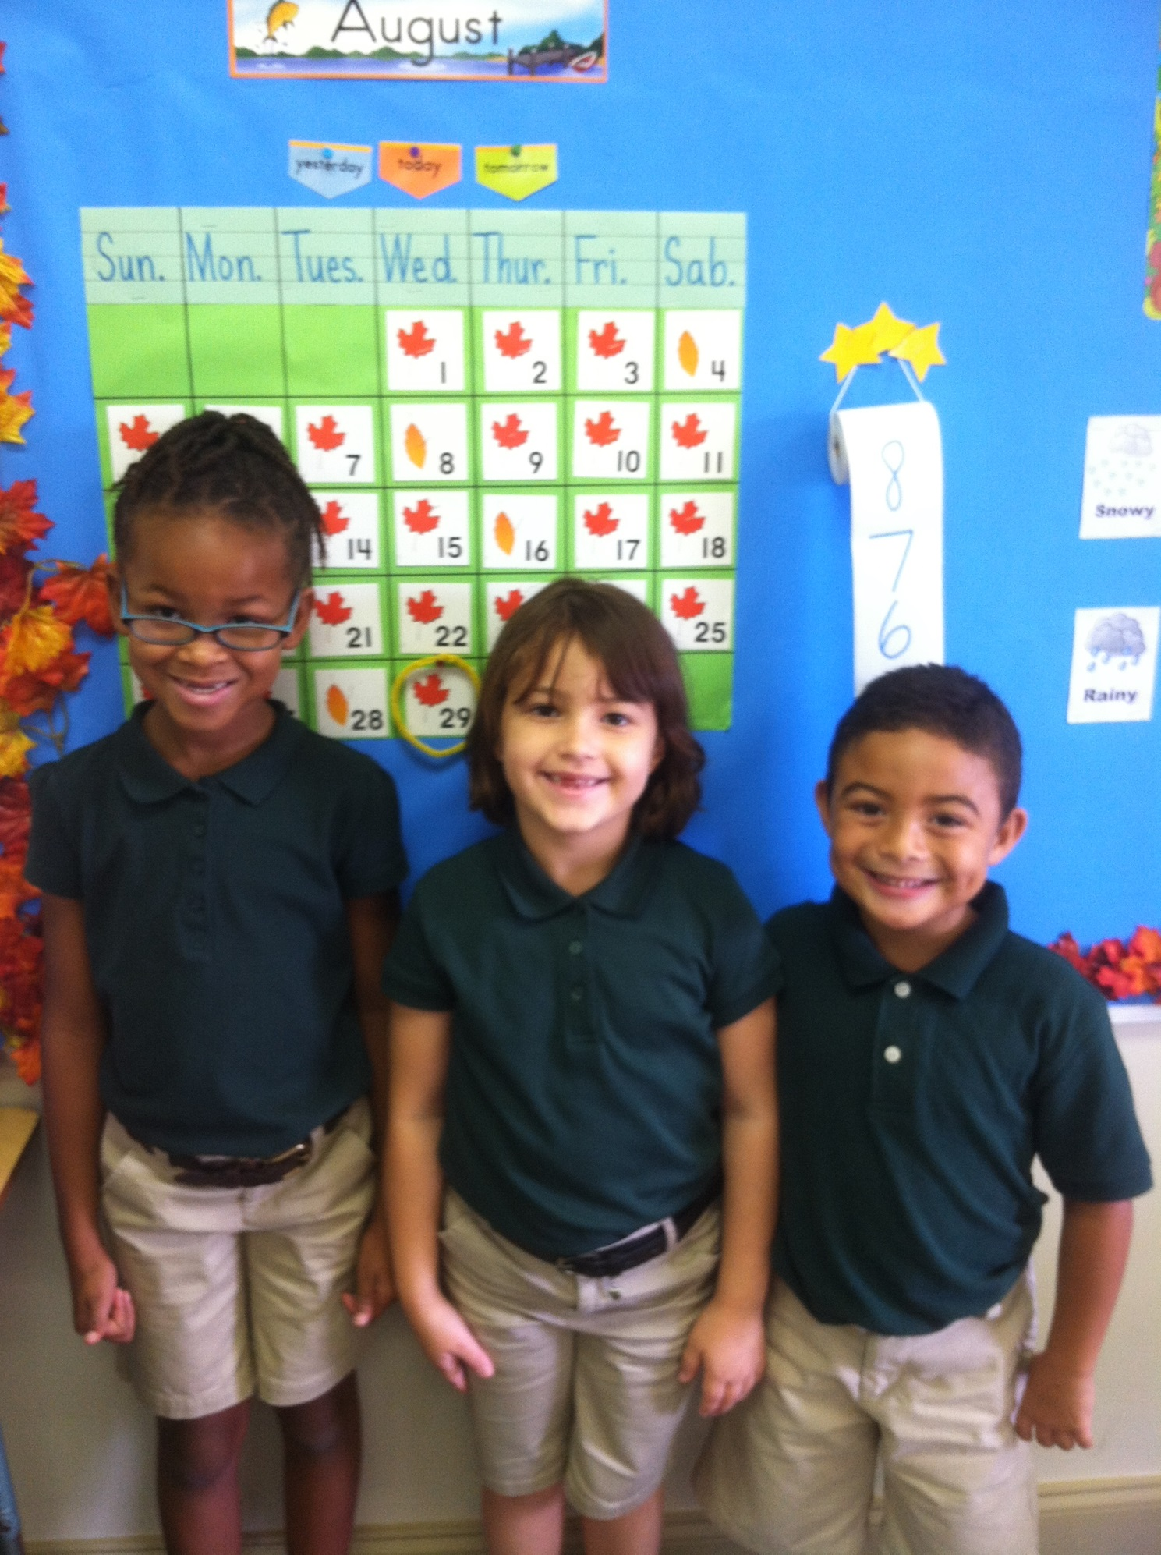

A Passion for Learning

2395 Fortune Road  
Kissimmee, Florida 34744

407.348.2226

oacsoffice@yahoo.com

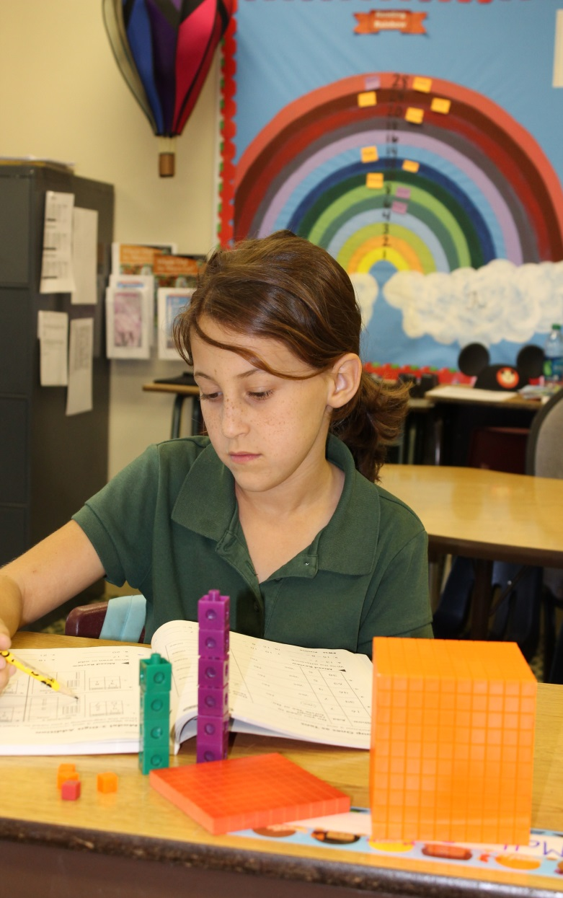

[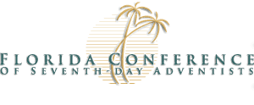](http://www.floridaconference.com/education/)

A Commitment

to Excellence

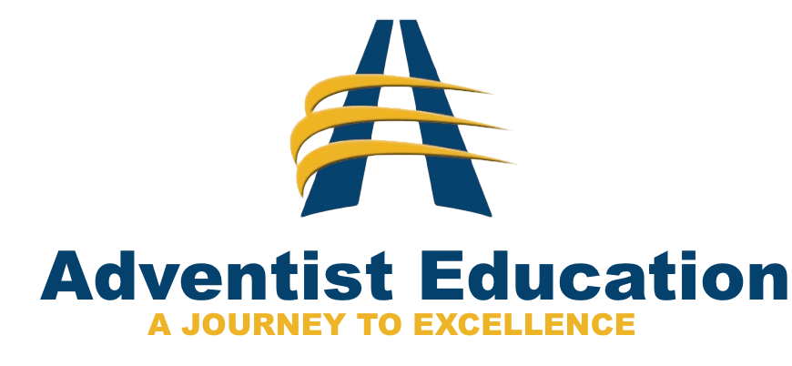

Osceola Adventist Christian School | Christian education with solid roots

Osceola Adventist Christian   
 School participates in the   
 Voluntary Prekindergarten   
 Program (VPK).   
  
Legislatively mandated, the VPK program is designed to prepare every four-year-old in Florida for kindergarten and build the foundation for their educational success. The VPK program gives each child an opportunity to perform better in school and throughout life with quality programs that include high literacy standards, accountability, appropriate curricula, substantial instruction periods, manageable class sizes, and qualified instructors. VPK is **FREE** for all four-year-olds born on or before September 1 who reside in Florida.  Hours are 8 am until 11:45 a.m., Monday through Friday.



It is both my pleasure and privilege to work with the students, parents, staff, and church community of Osceola Adventist Christian School (OACS) and the surrounding Kissimmee area. We are determined to provide all the children at OACS the best possible educational experience.

OACS students are exposed to a higher rigor of standards-based education based on the Adventist Philosophy of Education.  The Adventist Philosophy of Education has been in existence for 160 years.  It is the forerunner of the Montessori Method and Vygotsky’s Constructivism, and has some distinct similarities to both approaches, while incorporating the model found in the scriptures.  The OACS faculty, staff and school board are deeply dedicated to high quality, standards-based Christian education.  We are grounded in the Bible and progressive, on-going research in educational trends. As a co-educational, Christian school we are open to all faith communities.

Come partner with us on a journey that will enable your child to succeed in this world, and be prepared for eternity and the world to come.

Dr. Michael Cookenmaster, EdD  
 Principal

**Growing up in the 21st Century is not easy.**

Young people today face challenges, pressures and temptations that were unimaginable just a few years ago. In a world of confusion and constant change, parents increasingly look to Adventist education to offer their children the tools they need to survive and succeed.

**Academically, the numbers speak for themselves!**

|  |  |  |
| --- | --- | --- |
|  | **Adventist**  **Schools** | **Public**  **Schools** |
| % of graduates attending college | 85 | 66 |
| % of graduates who complete college | 80 | 14 |
| % of applicants accepted to medical school | 34 | 9 |

[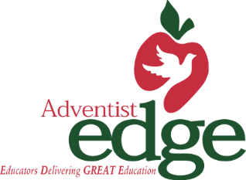](http://www.sacsda.org/department/13--Education)[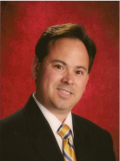](http://osceola22.adventistschoolconnect.org/site/1/docs/Cookenmaster1Bio.pdf)[](http://images.search.yahoo.com/images/view;_ylt=A0PDoQ3T335RfEIAT0yJzbkF;_ylu=X3oDMTBlMTQ4cGxyBHNlYwNzcgRzbGsDaW1n?back=http://images.search.yahoo.com/search/images?p=internet+logo&_adv_prop=image&va=internet+logo&fr=yfp-t-900&tab=organic&ri=192&w=578&h=534&imgurl=peterfaur.com/wp-content/uploads/2011/03/internet-kids-logo.jpg&rurl=http://peterfaur.com/2011/03/30/great-websites-for-kids&size=147.4KB&name=%3cb%3einternet%3c/b%3e-kids-%3cb%3elogo%3c/b%3e&p=internet+logo&oid=930e5b94afa1fd4b908ca808148c5825&fr2=&fr=yfp-t-900&tt=%3cb%3einternet%3c/b%3e-kids-%3cb%3elogo%3c/b%3e&b=181&ni=48&no=192&ts=&tab=organic&sigr=11n6od38a&sigb=13t2cjp1l&sigi=11v7dtmc1&.crumb=F1EOyAeHe09&fr=yfp-t-900)

When it comes to your child’s education, there is no investment too large; no sacrifice too great!

The most important things cannot be measured in achievement test scores. Osceola Adventist Christian School (OACS) is a part of a world-wide education movement with more than 6,709 schools and through the inspired efforts of more than 65,679 Adventist teachers, young lives experience critical transformation!

It happens in morning worship, through earnest prayer, and community service projects. In so many little ways each day, children who attend OACS find a daily relationship with the creator God. Isn’t that worth everything?

**Visit us online at**

[www.osceola22.adventistschoolconnect.org](http://www.osceola22.adventistschoolconnect.org)

**Call 407.348.2226 for a registration packet.**

Place real estate logos here